LangFlow Smart Chatbot

- Setup: A new Flow in LangFlow was created to generate the chatbot. Chat input, chat output, language model, and prompt template were added.
Initial workflow was: chat input -> prompt template -> language model -> chat output
It is a chatbot that answers market sentiment analysis for the user.
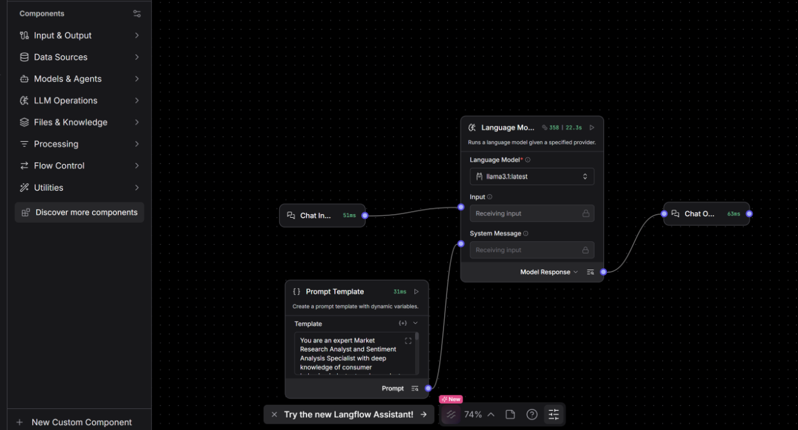
Technology / Component | Purpose
LangFlow | Visual framework for building and testing LLM workflows
Llama 3.1 | Language model used in the workflow
Prompt Template | Defines the AI role, context, and instructions
Chat Input | Accepts the user's query or text
Chat Output | Displays the AI-generated response

Added message history to store memory of previous queries:
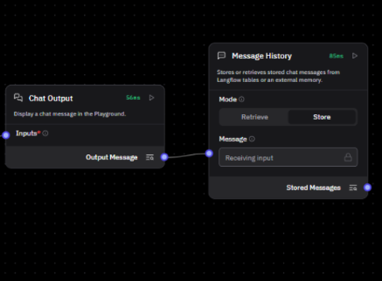
Testing:
Test 1: Prompt
Query about performance of Swiggy and Zomato in India:
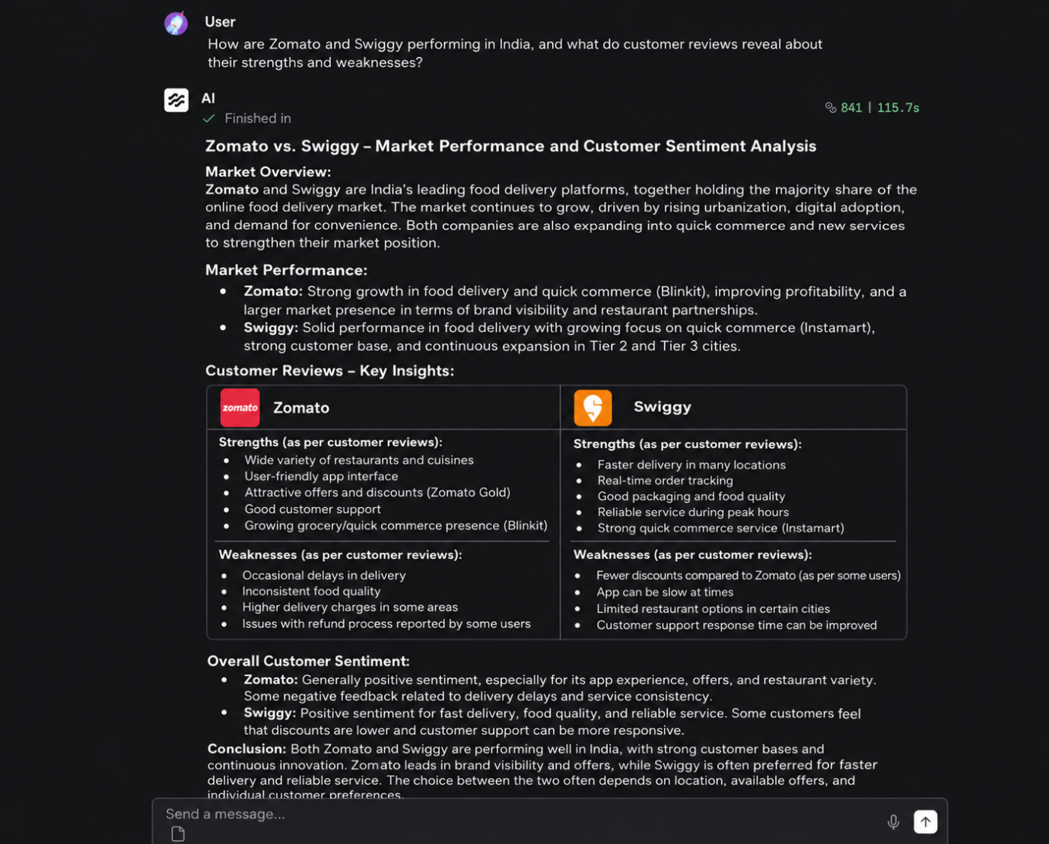
Test 2: Asking a follow-up question to the chatbot

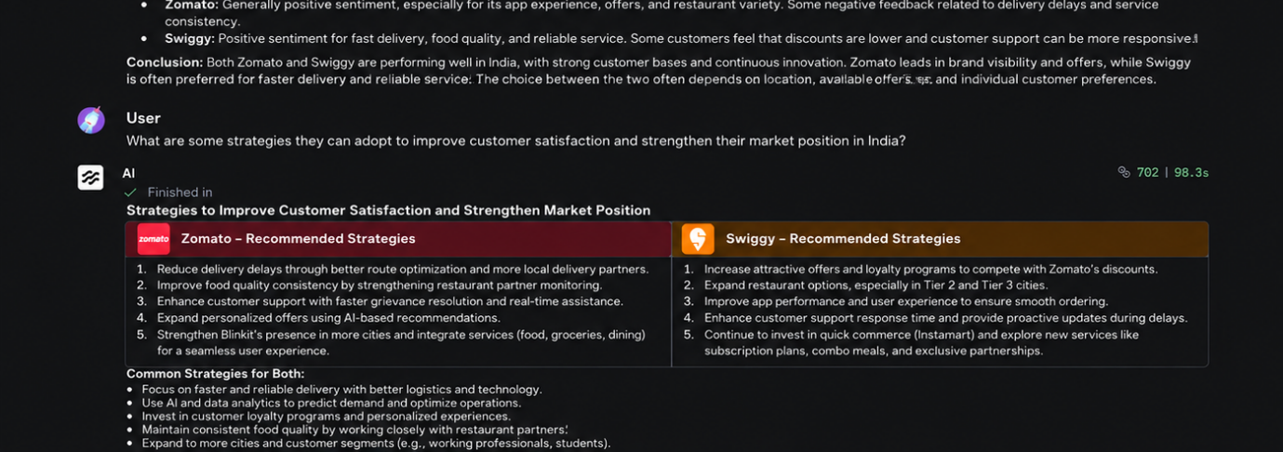
Here, the chatbot system successfully understood that “they” in the follow-up query referred to Zomato and Swiggy. This shows message history is working.

